Assignment 1 – Design Report

Name: Isaac Carew

Student number: 20118124

Course: Computer Science

Class Group: W2

Brief Overview:
In this website I plan to have:
- A home page
- A page with general info about me.
- A page about my interests.
- A page about my achievements.
- A page of pictures.
- I will use flex boxes and tables as the main formatting components for my webpage.

Wireframes:

Home page:
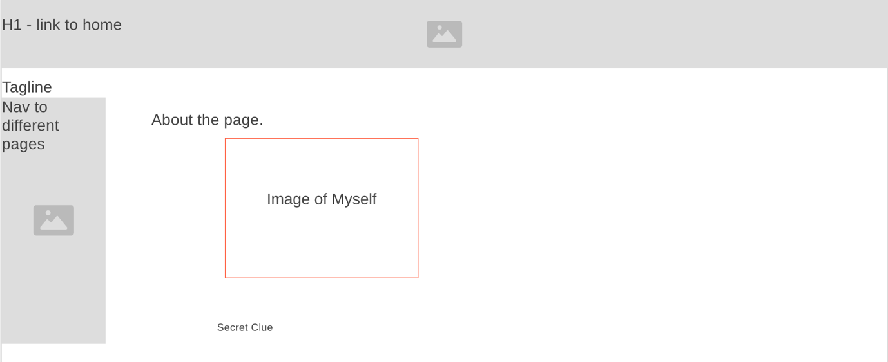

About me page:
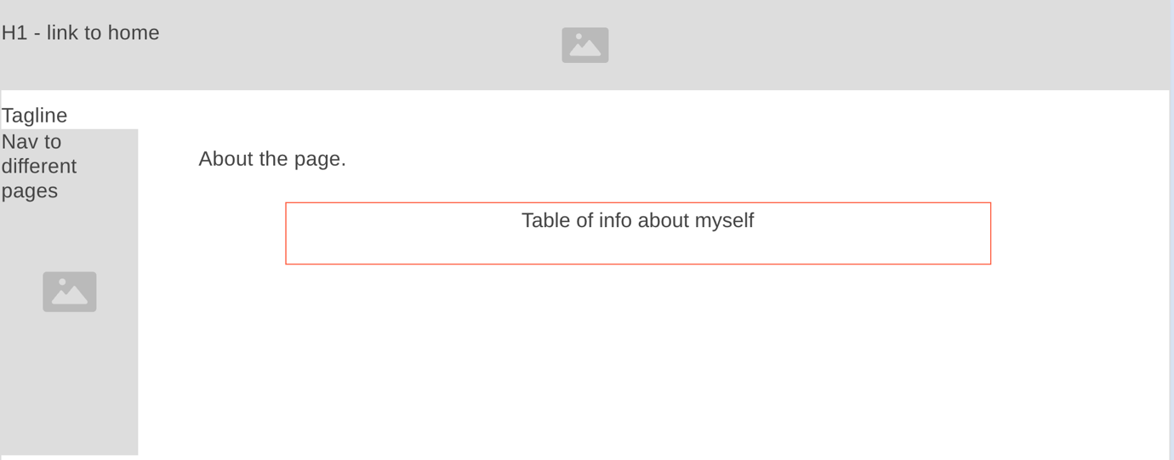

Interests Page:
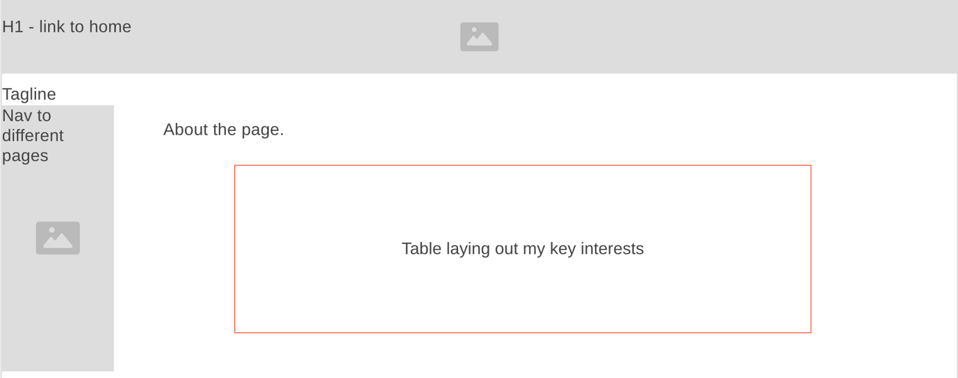

Achievements Page:
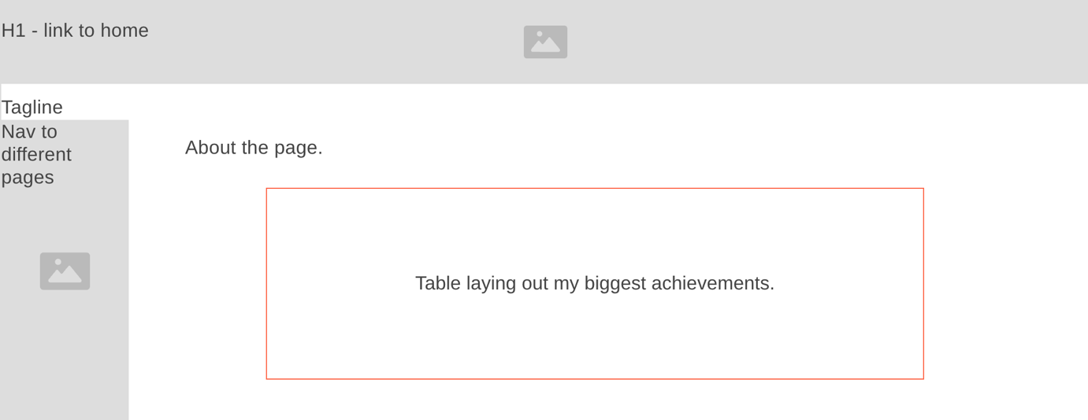

Photo Gallery Page:
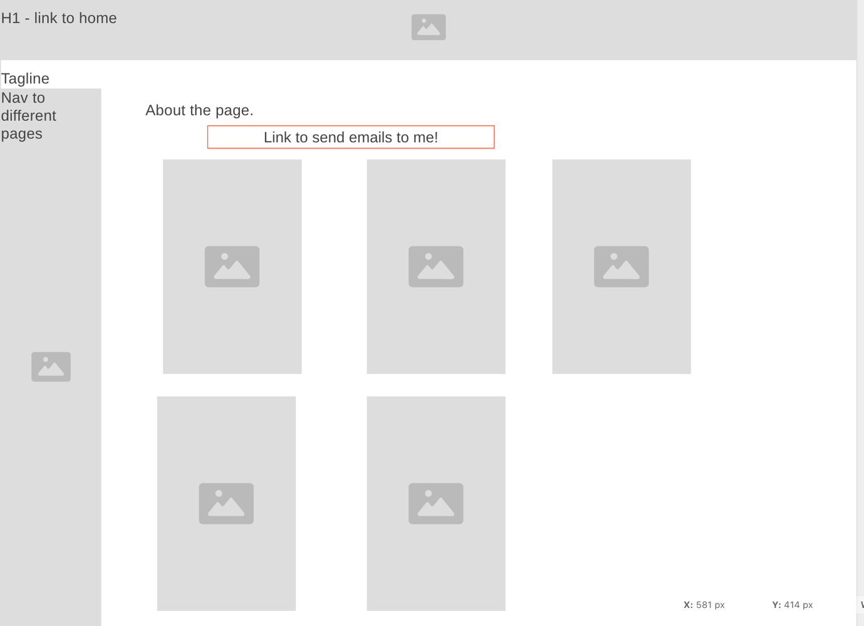

Visual Design:
- For my visual design I mainly want to use tables to display pieces if info about me.
- For my nav the background will be the flag of Ireland.
- For my heading of the page I will have a city skyline background with the content throughout following the grey, black, blue, purple colour scheme for the most part.
- For fonts I will just keep it simple and use fonts like ariel or Helvetica.

